Editing Approved Event Registrations Responses
Before You Start
- Manager-only questions may be restricted to Institution managers during the setup process. Please check the event setup to see the ‘Minimum Hierarchy View’ and ‘Minimum Hierarchy Edit’ settings of each Manager only question to determine if county managers may see and/or edit registration responses for that question.
- Responses to custom questions that have fees may NOT be edited after approval. The registration must be sent back before approval to change the response.

Steps  - Click on the Registrations tab in the navigation pane.  - Search for the event and select the registration record you wish to modify. | Screenshots  (Screen appearance may vary per state)  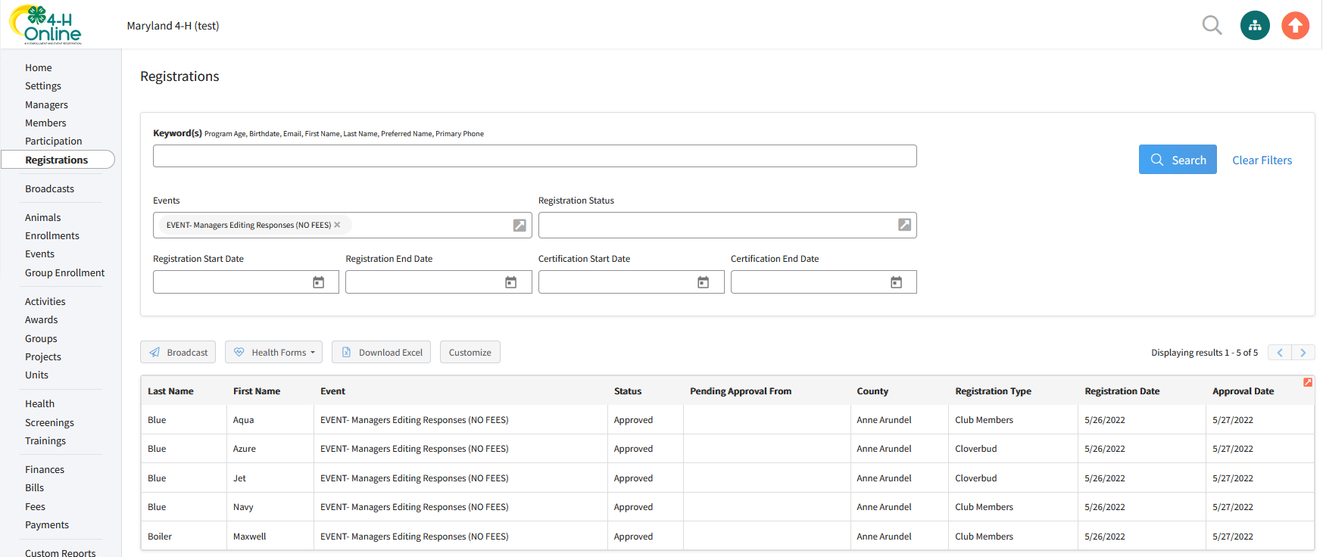
- Click Edit on the ‘Other Questions’ section.  - A pop-up window will appear. Edit the response as needed and click Save. | 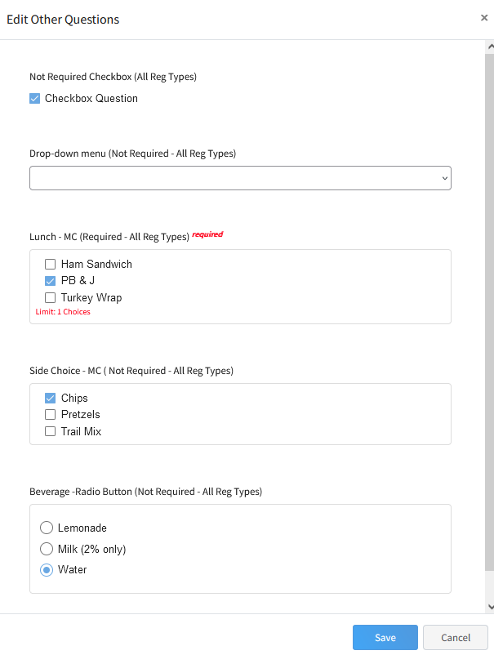
Tips
- All questions marked as Required must have a response before the Save button becomes active.
- If questions with limits on choices, the registration may not have more selections that what is allowed.

